5 Point Assignments
20-30 Minutes to complete
Name | Type | Description
Acrostic Poem |  | A word from the unit is written vertically and then each letter is used to start each line of a descriptive poem.  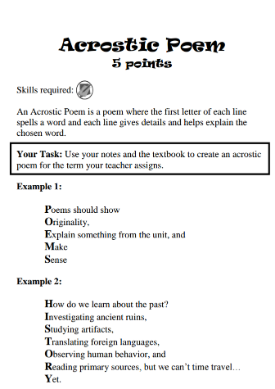
Advertisement |  | Create a print advertisement for an invention from the given civilization.  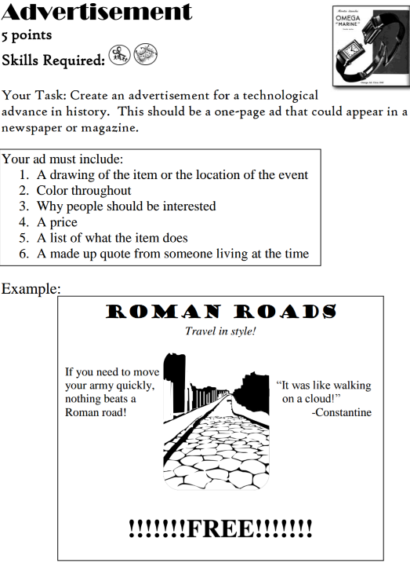
Advice  Letter |  | Write a letter to a historical figure giving him or her advice on a problem.  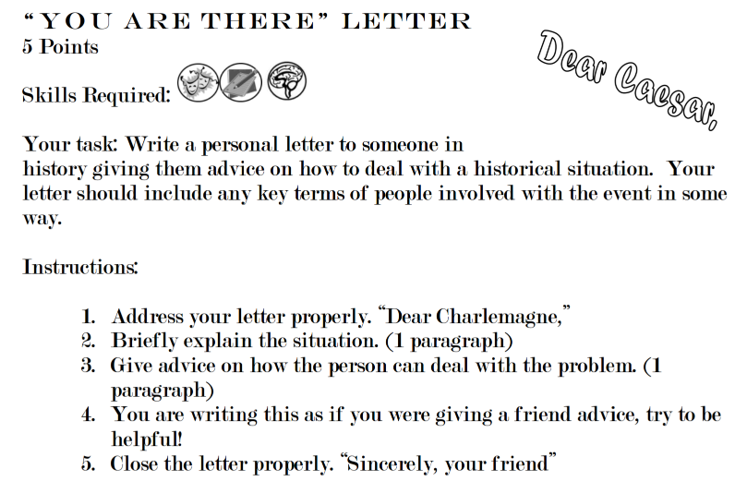
Be the Thing |  | Write a short explanation of the life experience of a particular object from history like Da Vinci's first paintbrush.  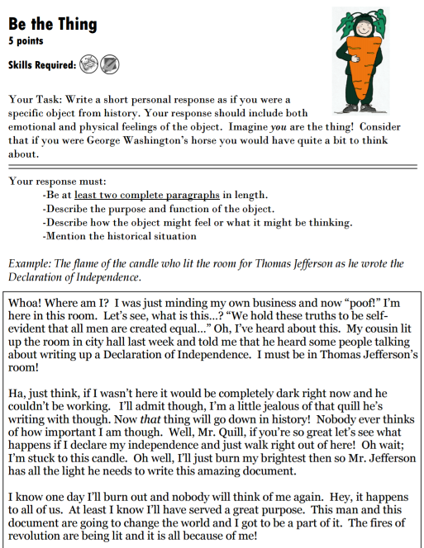
Bio-poem |  | Complete a poem with a pre-made layout about a specific person or group in history.  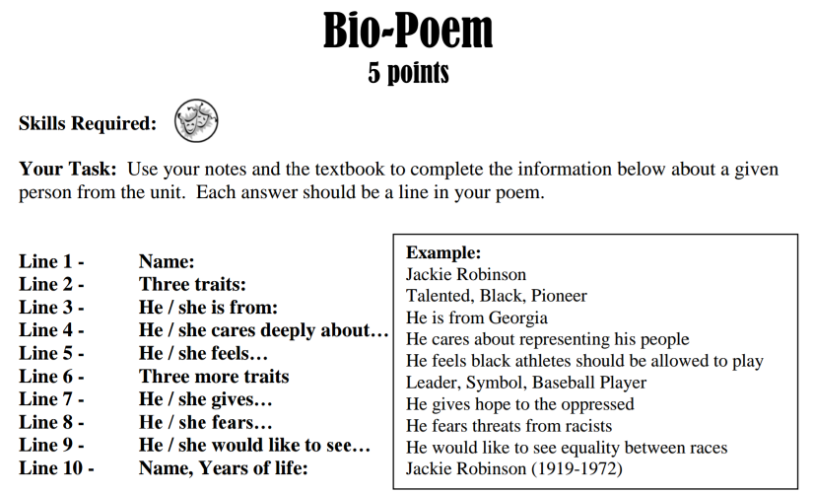
Bumper Sticker |  | Create a witty bumper sticker about a specific topic. Recommended only for highly creative students.  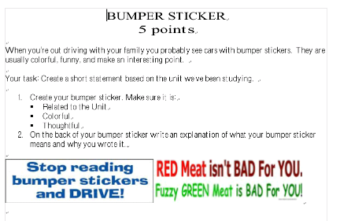
Cause and Effect Chain |  | Describe two causes and two effects for a given historical event.  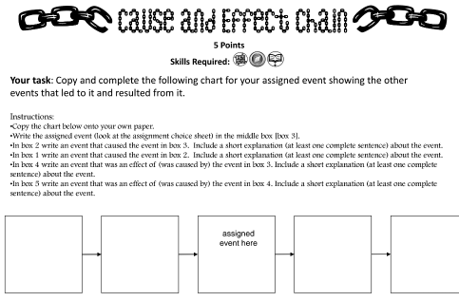
Caution! |  | Create a caution sign warning people about something dangerous from a civilization.
Countdown! |  | Complete a 5-stage graphic organizer including key terms, review questions and a symbol.  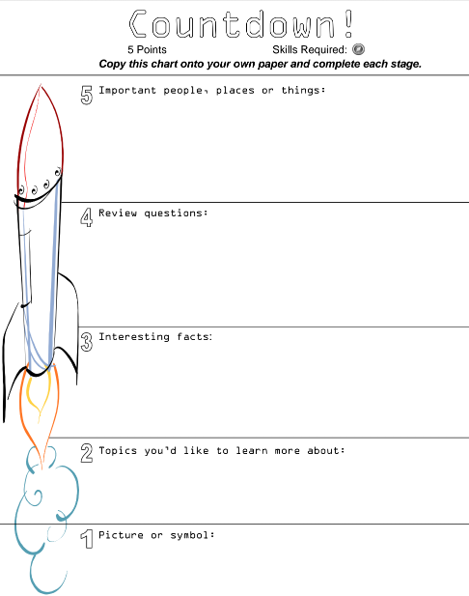
Game On! |  | Design a game that could be played in a civilization we've studied. Consider the impact of their geography and culture.  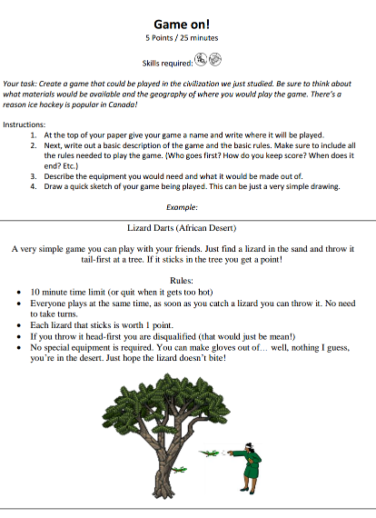
Neo Venn Diagram |  | Like a Venn Diagram only less reliant on drawing properly sized circles (which I can't do...)  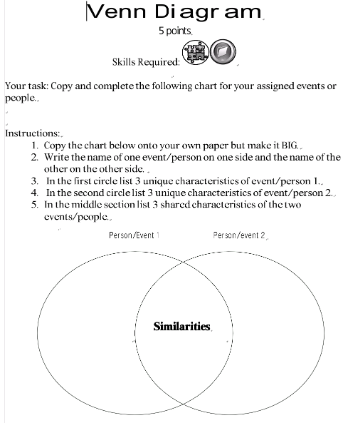
Picture Analysis |  | Answer a series of thought-provoking analysis questions about a photograph or piece of art.  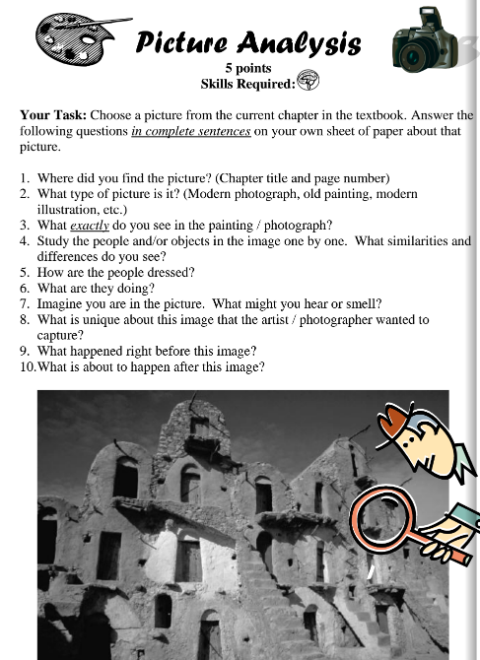
Post Card From The Past |  | Make a postcard as if you were visiting an ancient civilization.  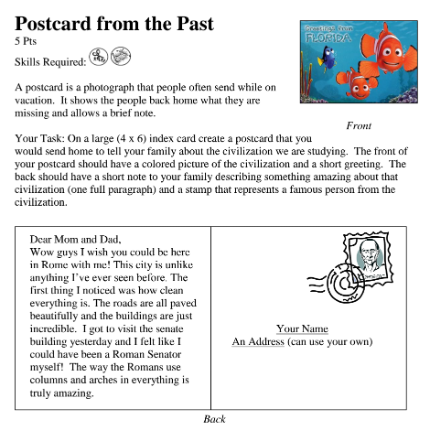
TXT MSG |  | Write a summary of a historical event in the form of a text message to a friend.  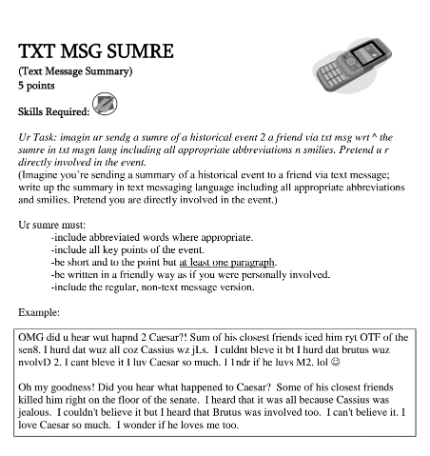
Venn Diagram |  | Complete a Venn Diagram (kinda...) to compare and contract two historical figures, events or civilizations.
Wanted Poster |  | Create a wanted (or hero) poster for a person from history.  