40 Point Assignments
All 40 point assignments require significant work outside of class and take up to 4 hours to complete.
Name | Type | Description
Bloom Ball |  | Create a soccer ball shaped graphic organizer that represents different aspects of a civilization.  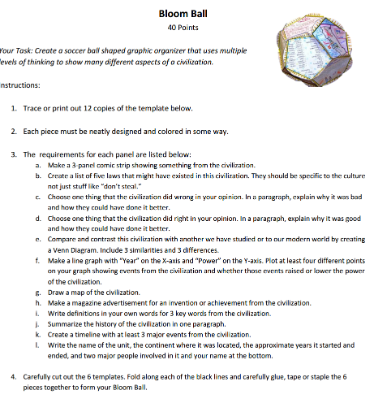  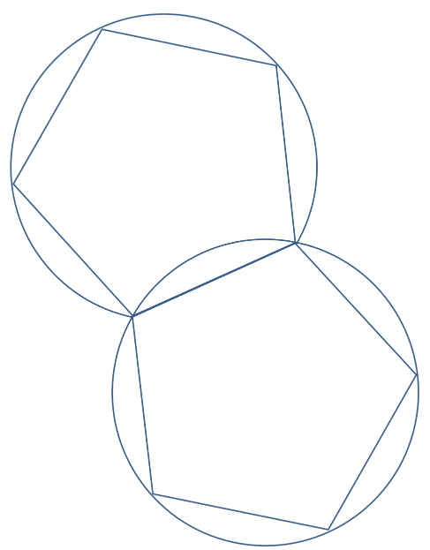
Board Game |  | Create a board game using historical information. Be creative and follow directions carefully.  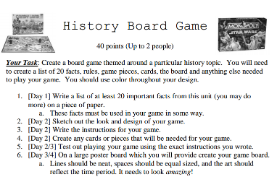
Model |  | Write a report on and build a model of a historical object or location.  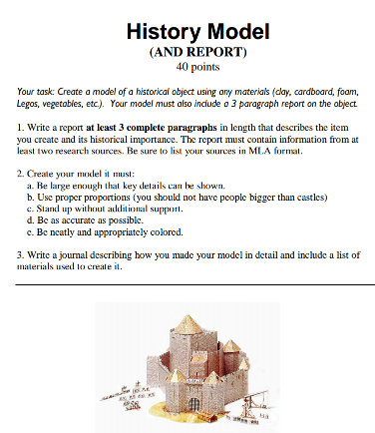
Newspaper |  | Working with a partner create a newspaper with sports reports, comic strips, ads and other articles about a civilization.  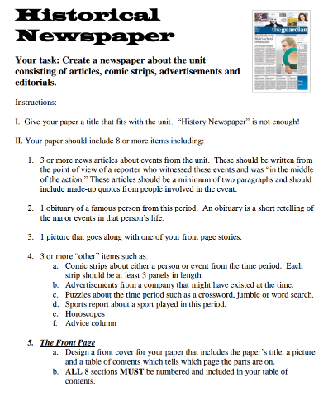
Mind Map |  | Create a large word cluster using terms from the unit. Then write sentences explaining how the words are connected. It is basically a very large Brain Chain.  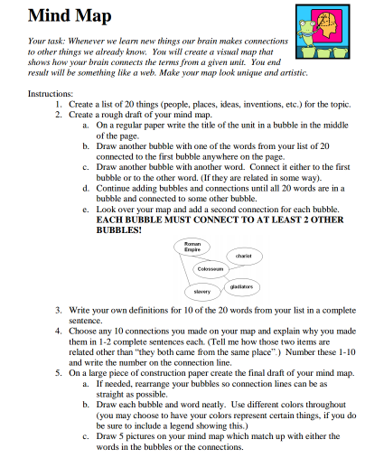
Teacher |  | Create a Prezi presentation on a topic. It must be at least as good as what you see from me in class! See me for further details…
Textbook Remix |  | Create a textbook section on a topic from history. Our textbook is terrible so help me make a better one!

