20 Point Assignments
90 minutes to complete
Name | Type | Description
Civilization in a Bag |  | Find 5 modern items that represent different aspects of a civilization and use them to report on the civilization.  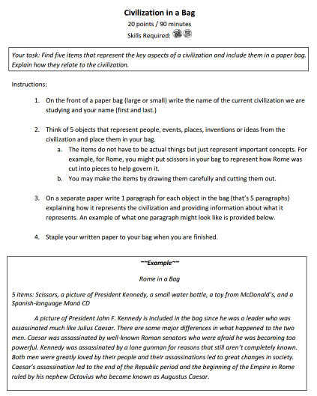
Create a Crossword |  | Make your own electronic crossword puzzle using ALL terms from the current unit.  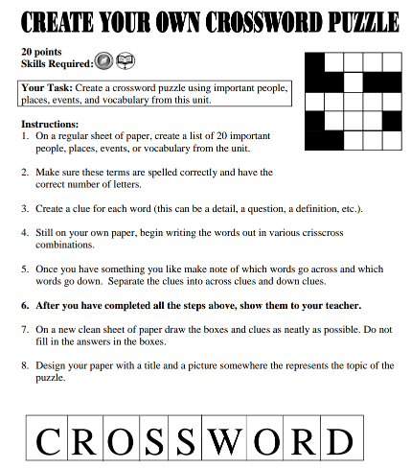
History |  | Write a creative fictional story using key terms and figures from the unit.  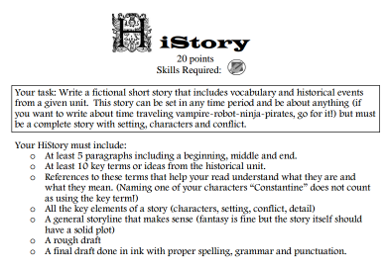
Letters Home |  | Write a series of 3-4 letters home as if you were traveling on a long journey.  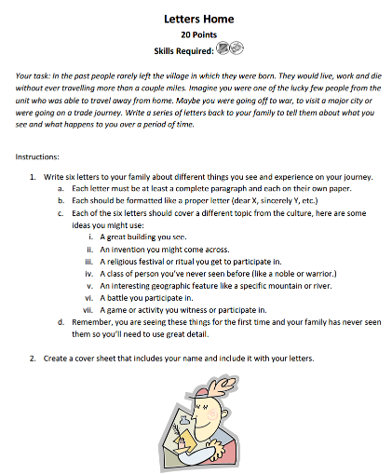
Magazine Cover |  | Design a one-page magazine cover for a given section of the textbook.  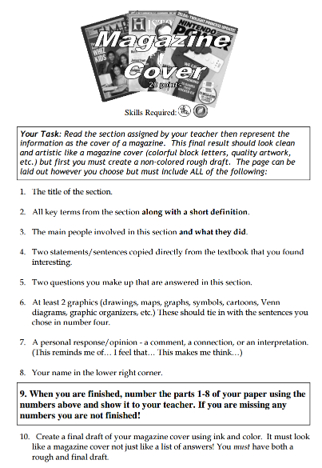
Movie Madness |  | Use art and writing to recreate a given unit as a movie. Includes designing a movie poster and writing a movie review.  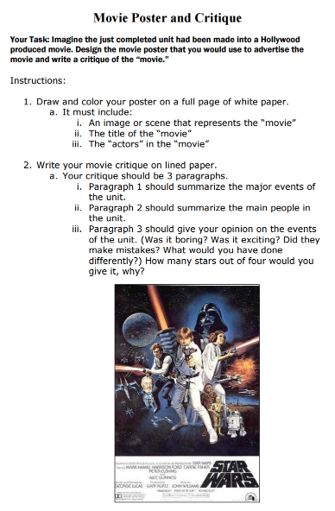
Paper Bag Puppet |  | Create a puppet of a historical figure along with a list of statements that person might say.  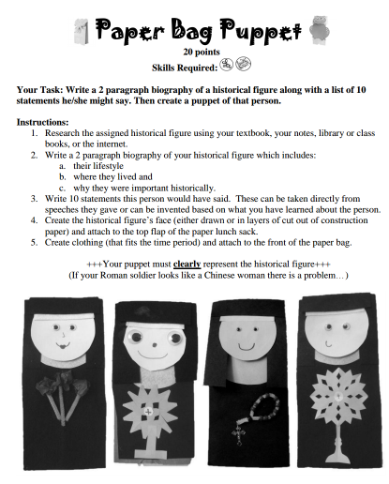
Picture Book |  | Create a children's book about a given topic. Kindergarten age  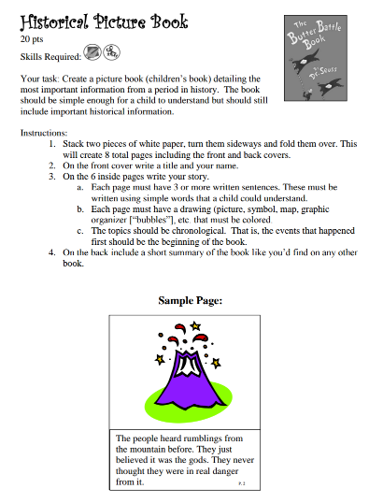
Play |  | Write and perform a short play about a historical event. Completed in pairs or small groups 2-3.  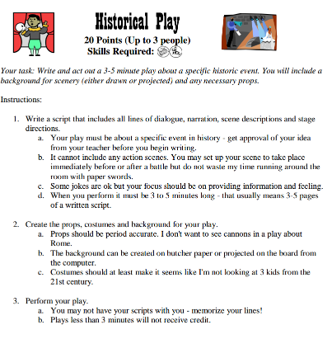
Pop Culture |  | Create a "pop-up" 3D display of the key aspects of a culture.  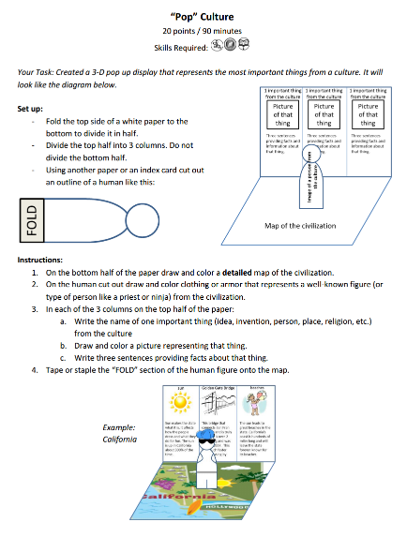
Social Network |  | Create a social network page for a historical figure  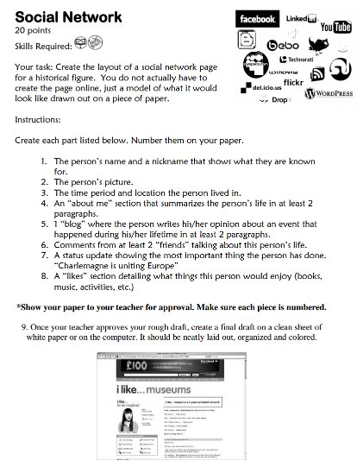
Storyboard |  | Create a storyboard layout for a movie based on a historical event.  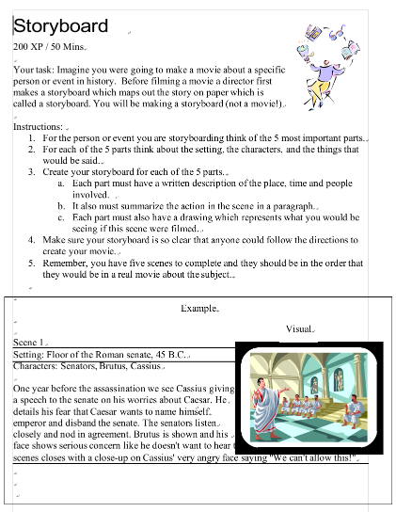
Travel Brochure |  | Create a six-panel foldout brochure that highlights the history, hot spots, and accommodations of a civilization. You also get to design an amusement park!  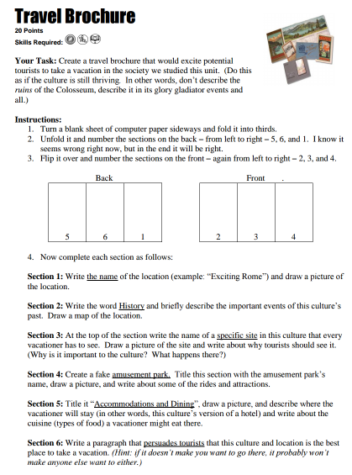
Web Page |  | Create the layout for a web page about a specific topic from the unit.  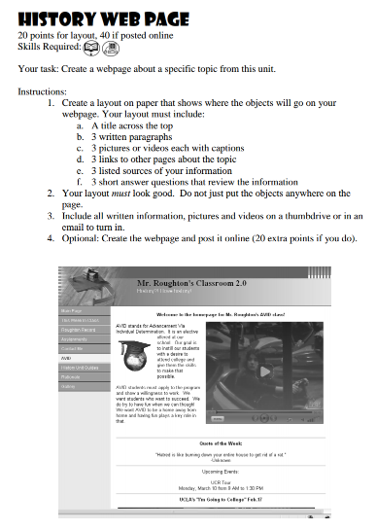
What If?  Aka: Fracture |  | Flip the script on an event in history. Change one major detail from the event then speculate how this would have changed the outcome. Show your results in a recreated textbook page.  