10 Point Assignments
45 minutes to complete
Name | Type | Description
Annotated Illustration |  | Students draw a full-page picture of a historical object or location and write 6 captions to describe it.  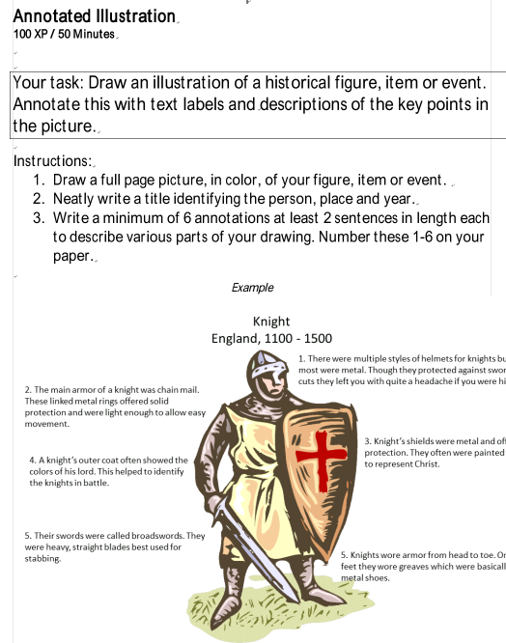
Brain Chain |  | List 10 important people, events, concepts, etc. and 5 generic history terms then create conceptual links between them in a graphic organizer.  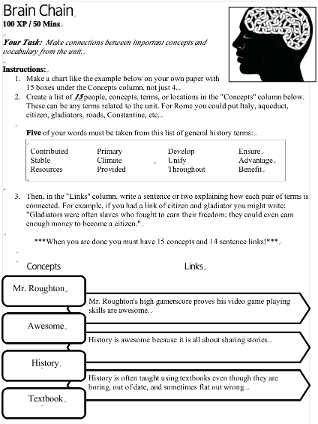
Character Clash! |  | Complete two bio-poems side to side to highlight the similarities and differences between two historical figures or groups.  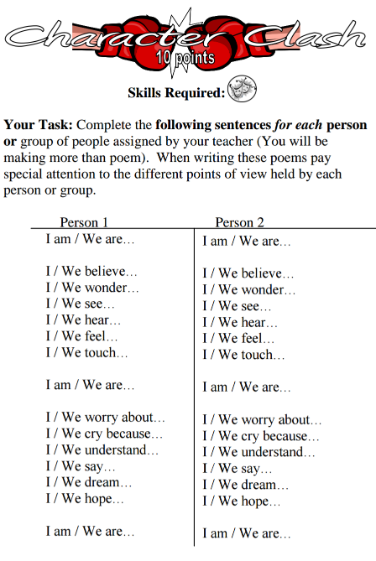
Circle Summary |  | Complete a graphic organizer as a history unit summary. Requires the unit to be broken down into 5 parts to work as shown here.  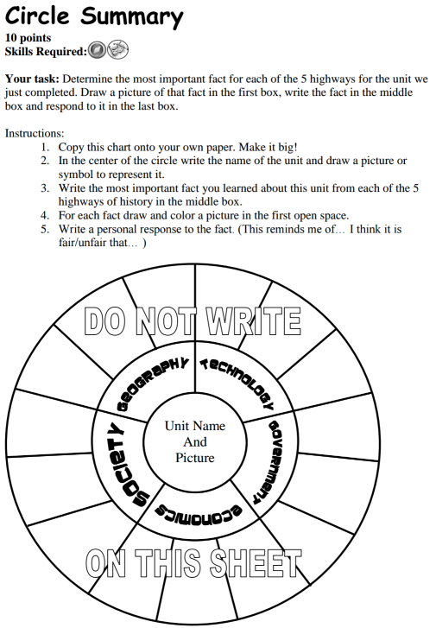
Comic Strip |  | Create a 3-5 panel comic strip showing an event from a historical perspective.  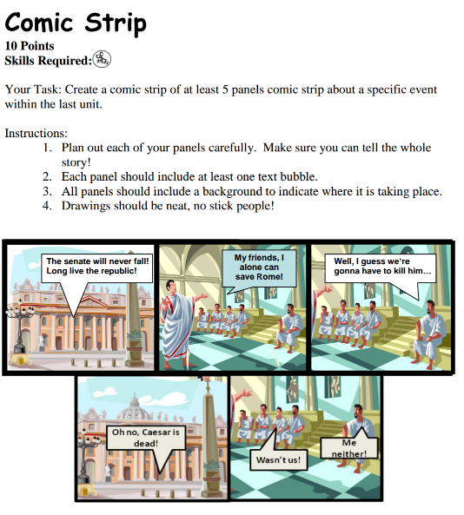
Dear Diary |  | Write a series of diary entries as if you were a person in history truly experiencing a historical event.  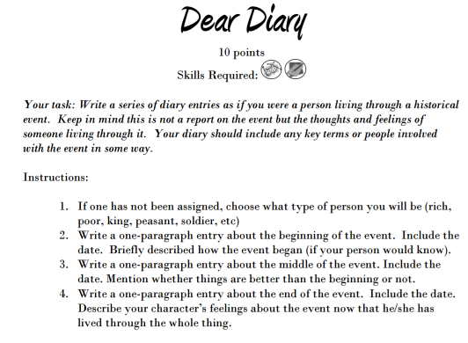
Illustrated Timeline |  | Draw a timeline and add captions or small pictures to bring it to life.  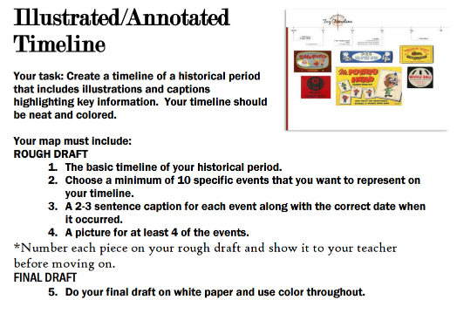
Introduction Speech |  | Write and recite an introductory speech for a historical figure. May require outside research.  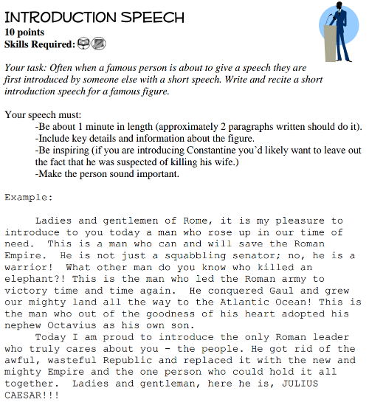
Invitation |  | Create an invitation (the who, what, when, where, what to bring, etc.) to a historical event we studied in the unit.  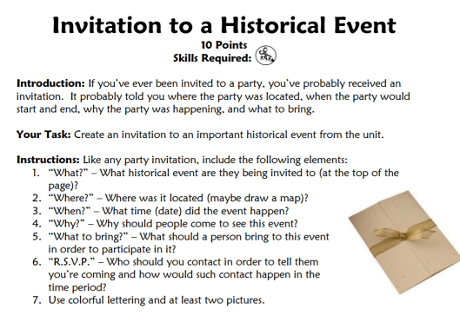
Legal Brief |  | Write a legal defense for a historical figure who may have committed a crime.  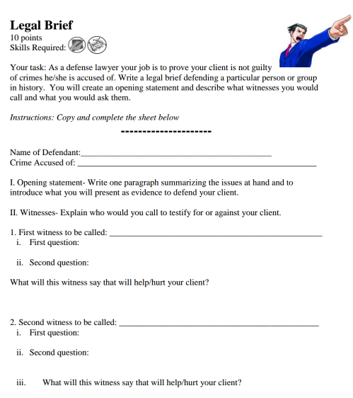
Mannequin |  | Draw the clothing a historical figure would likely wear and describe some of his/her inner thoughts and feelings.  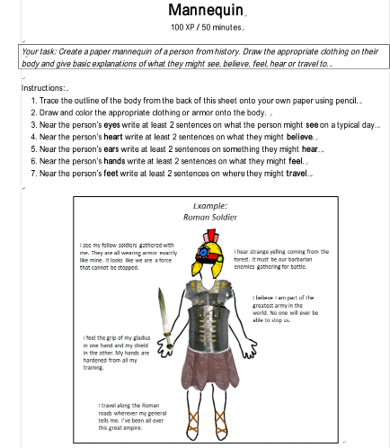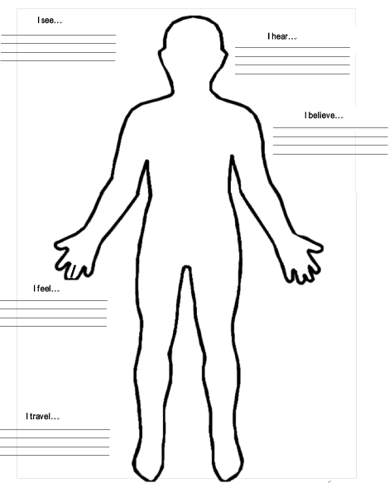
Personal Pyramid |  | Create a 3-D monument to memorialize a person from history.  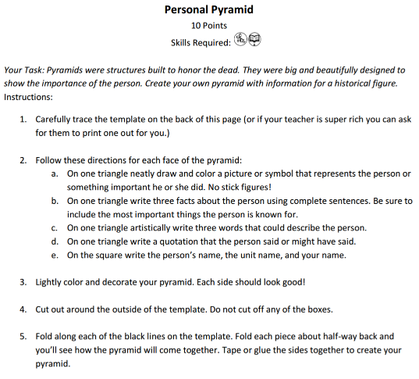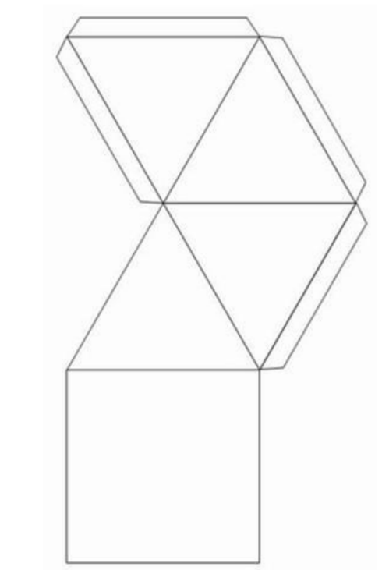
Recipe for a Civilization |  | Write a recipe with a list of ingredients it would take to create a given civilization. This definitely requires abstract thinking.  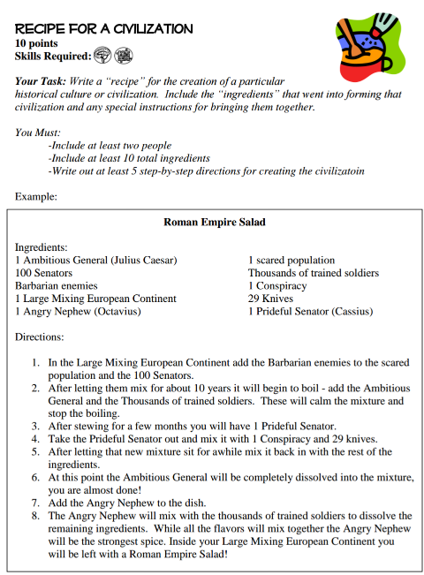
Song Rewrite |  | Rewrite the lyrics to a song to make it about a historical period.  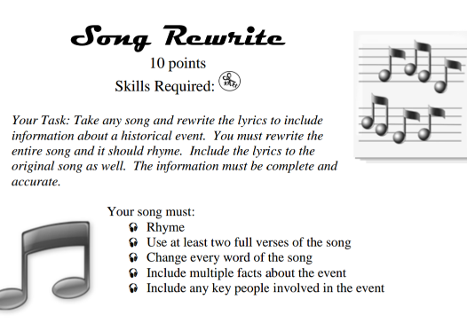
Worlds Collide |  | Draw pictures contrasting key points of two civilizations.  