6th Grade Social Studies EXAM STUDY GUIDE

|  |  |
| --- | --- |
| Europe Geography: Locate and label the LANDFORMS! | |
| [Europe Map](http://faculty.uml.edu/ccarlsmith/teaching/maps/europe.jpg) | Mediterranean Sea |
| Rhine  River |
| Danube  River |
| English  Channel |
| European  Plain |
| Alps  Mountains |
| Pyrenees Mountains |
| Ural  Mountains |
| Iberian  Peninsula |
| Scandinavian Peninsula |

|  |  |  |  |  |  |  |  |  |  |
| --- | --- | --- | --- | --- | --- | --- | --- | --- | --- |
| Europe Geography: Locate and label the COUNTRIES! | | | | | | | | | |
| [Europe Map](http://faculty.uml.edu/ccarlsmith/teaching/maps/europe.jpg) | | | | | | | | | |
| United Kingdom | France | Belgium | Germany | Portugal | Poland | Ukraine | Russia | Spain | Italy |

**6th Social Studies Exam Study Guide** (Refer to class notes, online vocabulary and Power Points)

1. **Complete the Europe “LANDFORMS” and “COUNTRIES outline map**
2. Why is it important to compare languages when studying Europe? Which languages come from the language of the ancient Roman Empire?
3. How do Europeans solve the problem of having so many languages. What country in Europe has a central location, good farmland, many rivers, ocean access, many neighboring countries, and comfortable climate?
4. Why is the United Kingdom more reliant on ocean travel for trade than compared to Russia?
5. Describe the Alps and its relative location.
6. What mountain range divides the landmass of Eurasia into two continents, Europe and Asia
7. What are the three main religions in Europe? How are they similar? Different? What is the most common?
8. What was Prince Henry the Navigator’s role in exploration? Where did he want to go?
9. Why did European countries (Portugal, Spain, England, and France) want colonies? Provide colonies for the following countries:

Portugal:

Spain:

England:

France:

1. Why was slavery used in the New World?
2. What is meant by “Scramble for Africa”?How did European colonization in Africa and Asia contribute to the outbreak of World War I?
3. Which countries formed the Central Powers during World War I? The Allied Powers?
4. How did the Great War or World War I start? What were the purpose and requirements of the Treaty of Versailles?
5. What is the Russian Revolution? (Discuss people and events involved)
6. Which major historic genocide event is associated directly with World War II? Describe what happened.
7. Why was World War II a starting ground for the Cold War?

|  |
| --- |
| * France and Great Britain declared war on Germany. * Germany invaded Poland. * Adolph Hitler was named chancellor of Germany. * Germans were unhappy because of high unemployment and poverty due to economic depression. |

1. Put the following events in the order in which they happened. (You may use numbers!)
2. **Define each term:**

Colonization-

Nationalism-

Industrialization-

Militarism:

Alliance-

Imperialism-

Triangle Trade-

Nazism/Nazi Party: The Nationalist Socialist Party-

Holocaust-

Genocide-

**Directions: Correctly answer each statement below.**

1. What is the Cold War? (Include the Eastern Bloc and Western Bloc, Warsaw Pact and NATO in your discussion?
2. What do we call the dividing line between eastern and western Europe during the Cold War?What marked the end of the Cold War?
3. What branch of the government is made up of two houses?
4. **Fill in the chart below.**

|  |  |  |  |  |  |
| --- | --- | --- | --- | --- | --- |
|  | **Autocracy** | **Oligarchy** | **Democratic** | **Parliamentary Democracy** | **Presidential Democracy** |
| **Who holds the most power?** |  |  |  |  |  |
| **Other people/ groups that have power** |  |  |  |  |  |
| **Title of the leader** |  |  |  |  |  |
| **How does the leader come to power?** |  |  |  |  |  |
| **Do the citizens have rights?** |  |  |  |  |  |

**Define the following systems of government to determine the distribution of power:**

1. Unitary:
2. Confederation:
3. Federal:
4. Autocratic:
5. Oligarchic:
6. Democratic:
7. **Compare and contrast a president and prime minister.**
8. **Provide the correct responses to the statements below.**

|  |  |  |  |
| --- | --- | --- | --- |
| **Environmental Issues in Europe** | | | |
|  | **When did it happen?** | **What occurred during the event?** | **What is a possible solution?** |
| **Great London Fog** |  |  |  |
| **Acid Rain in Germany** |  |  |  |
| **Chernobyl Disaster** |  |  |  |

1. Define Personal Finance Terms: Credit, Opportunity Cost, Loan, Investing, Income, Expenses, Spending.

**LATIN AMERICA: GEOGRAPHY**

**SS6G1 The student will locate selected features of Latin America and the Caribbean.**

a. Locate on a world and regional political-physical map: Amazon River, Caribbean Sea, Gulf of

Mexico, Pacific Ocean, Panama Canal, Andes Mountains, Sierra Madre Mountains, and

Atacama Desert.

b. Locate on a world and regional political-physical map the countries of Bolivia, Brazil, Colombia, Cuba, Haiti, Mexico, Panama, and Venezuela.

**Locate and label standard a and b on the map.**

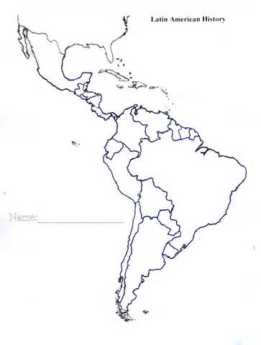

**SS6G2 The student will discuss environmental issues in Latin America.**

a. Explain the major environmental concerns of Latin America regarding the issues of air pollution in Mexico City, Mexico, the destruction of the rain forest in Brazil, and oil-related pollution in Venezuela.

Complete **Environmental Issues in Latin America**

**Mexico City: Air Pollution**

**Cause:**

**Effects:**



**Brazil: Destruction of the Rainforest**

**Cause:**

**Effects:**



**Venezuela: Oil Pollution**

**Cause:**

**Effects:**



**SS6G3 The student will explain the impact of location, climate, distribution of natural resources, and population distribution on Latin America and the Caribbean.**

a. Compare how the location, climate, and natural resources of Mexico and Venezuela affect

where people live and how they trade.

.

**Complete the Mexico and Venezuela Organizer**

**Location & Climate**

**L: Central America, borders US and Gulf of Mexico,**

**C: hot and dry**

**Comparison**

**Warm climates near equator**

**Border Caribbean Sea**

**Location & Climate**

**L: Brazil to the south, Caribbean Sea to north, Columbia to west and West, east Guyana**

**C: Tropical**

**Brazil**

**Mexico**

**Comparison**

**Gold, oil, natural gas**

**Natural Resources**

**Oil, iron ore, gold, diamonds, natural gas**

**Natural Resources**

**Gold, natural gas, silver, copper, timber, oil**

**In which two countries would you prefer to live? Use your information on location, climate, and natural resources to support your answer.**

**Where People Live and Why**

**Urban: 88%**

**4 Major Seaports,**

**Trade farm products**

**Comparison**

**Most of population live urban areas**

**Trade farm products on seaports**

**Where People Live and Why**

**Urban: 77%**

**7 Major Seaports,**

**Trade farm products**

b. Compare how the location, climate, and natural resources of Brazil and Cuba affect where

people live and how they trade

**Complete the Brazil and Cuba Organizer**

**Location & Climate**

**L: Gulf of Mexico northwest, Atlantic Ocean northeast**

**C: Tropical, rainy season**

**Location & Climate**

**L: East side of Brazil bordering the Atlantic Ocean**

**C: Tropical, temperate**

**Comparison**

**Tropical**

**Flat lowlands, plains, mountains**

**Venezuela**

**Natural Resources**

**Nickel, iron ore, chromium, copper, salt timber, petroleum**

**Cuba**

**Comparison**

**Iron ore, nickel, timber, petroleum, sugar**

**Comparison**

**Export sugar, coffee,**

**Tourism**

**Where People Live and Why**

**Cities: 76% in coastal areas**

**Trade and tourism**

**Natural Resources**

**Bauxite, gold, iron ore, manganese, nickel. tin, petroleum, timber**

**Where People Live and Why**

**Cities: 84% in coastal areas**

**Trade and tourism**

**_____________________________________________________________________________________________**

**SS6G4 The student will describe the cultural characteristics of people who live in Latin America and the Caribbean.**

a. Describe the results of blending of ethnic groups in Latin America and the Caribbean.

b Explain why Latin America is a region based on the languages of Portuguese and Spanish.

c. Evaluate how the literacy rate affects the standard of living.

**LATIN AMERICA: GOVERNMENT**

**SS6CG1 The student will compare and contrast various forms of government.**

1. Describe the ways government systems distribute power: unitary, confederation, and federal.

**Unitary –**

**Confederation –**

**Federal –**

b. Explain how governments determine citizen participation: autocratic, oligarchic, and democratic.

**Autocratic –**

**Oligarchic –**

**Democratic –**

Describe the two predominate forms of democratic governments: parliamentary and presidential.

**Parliamentary Democracy –**

**Presidential Democracy –**

**SS6CG2 The student will explain the structures of national governments in Latin America and the Caribbean.**

a. Compare the federal-republican systems of the Federative Republic of Brazil (Brazil) and the United Mexican States (Mexico) to the dictatorship of the Republic of Cuba (Cuba), distinguishing the form of leadership and the role of the citizen in terms of voting and personal freedoms.

**Governments**

**Brazil Mexico**

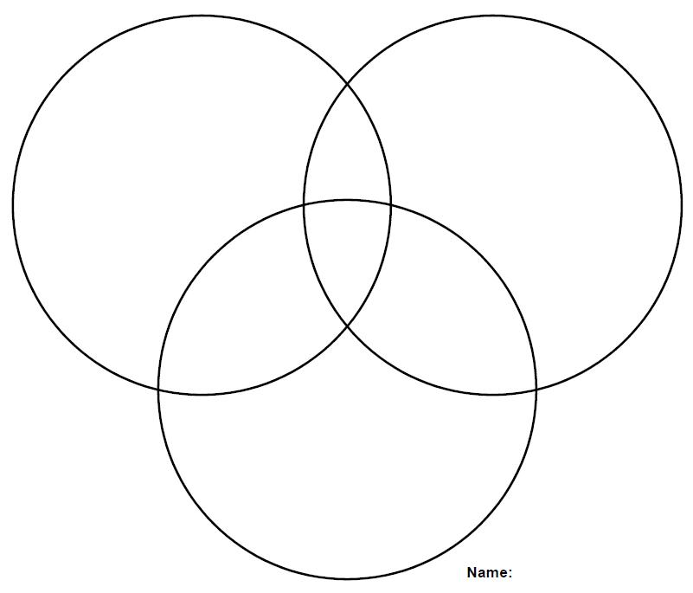

**Cuba**

**LATIN AMERICA: ECONOMICS**

**SS6E1 The student will analyze different economic systems.**

a. Compare how traditional, command, and market, economies answer the economic questions of 1-what to produce, 2-how to produce, and 3-for whom to produce.

**Traditional –**

**Command –**

**Market –**

b. Explain how most countries have a mixed economy located on a continuum between pure market and pure command.

c. Compare and contrast the basic types of economic systems found in Mexico, Cuba, and Brazil.

**Economic Systems**

**Mexico Cuba**



**Brazil**

**SS6E2 The student will give examples of how voluntary trade benefits buyers and sellers in Latin America and the Caribbean.**

1. Explain how specialization encourages trade between countries.

b. Compare and contrast different types of trade barriers, such as tariffs, quotas, and embargos.

Tariffs –

Quotas –

Embargos –

c. Explain the functions of the North American Free Trade Agreement (NAFTA).

d. Explain why international trade requires a system for exchanging currencies between nations.

**SS6E3 The student will describe factors that influence economic growth and examine their presence or absence in Latin America.**

a. Explain the relationship between investment in human capital (education and training) and gross domestic product (GDP).

b. Explain the relationship between investment in capital (factories, machinery, and technology) and gross domestic product (GDP).

c. Describe the role of natural resources in a country’s economy

d. Describe the role of entrepreneurship.

**LATIN AMERICA: HISTORY**

**SS6H1 The student will describe the impact of European contact on Latin America.**

a. Describe the encounter and consequences of the conflict between the Spanish and the Aztecs and Incas and the roles of Cortes, Montezuma, Pizarro, and Atahualpa.

b. Explain the impact of the Columbian Exchange on Latin America and Europe in terms of the decline of the indigenous population, agricultural change, and the introduction of the horse.

**SS6H2 The student will explain the development of Latin America and the Caribbean from European colonies to independent nations.**

a.Describe the influence of African slavery on the development of the Americas.

b. Describe the influence of the Spanish and the Portuguese on the language and religions of Latin America.

c. Explain the Latin American independence movement; include the importance of Toussaint L’Ouverture, Simon Bolivar, and Miguel Hidalgo.

Toussaint L’Ouverture –

Simon Bolivar –

Miguel Hidalgo –

**SS6H3 The student will analyze important 20th century issues in Latin America and the Caribbean.**

a. Explain the impact of the Cuban Revolution.

b. Explain the impact and political outcomes of the Zapatista guerrilla movement in Mexico.

**AUSTRALIA: GEOGRAPHY**

**SS6G12 The student will be able to locate selected features of Australia.**

a. Locate on a world and regional political-physical map: the Great Barrier Reef, Coral Sea, Ayers Rock, and Great Victoria Desert.

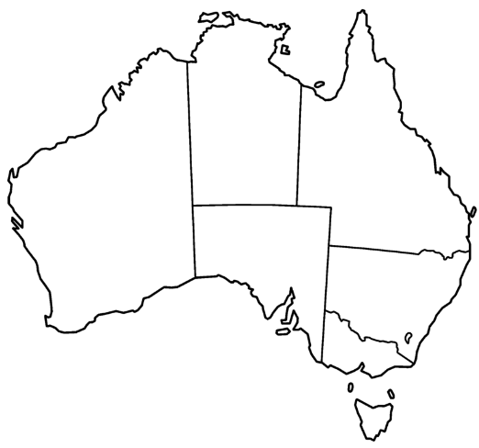

**SS6G13 The student will explain the impact of location, climate, distribution of natural resources, and population distribution on Australia.**

a. Describe how Australia’s location, climate, and natural resources have affected where people live.

1. Describe how Australia’s location, climate, and natural resources impact trade
2. **SS6G14 The student will describe the cultural characteristics of people who live in Australia.**

a. Explain the impact of English colonization on the language and religion of Australia.

b. Evaluate how the literacy rate affects the standard of living. __________________________________________________________________________________________________________________________________________________________________________________________

**AUSTRALIA: GOVERNMENT**

**SS6CG6 The student will compare and contrast various forms of government.**

a. Describe the ways government systems distribute power: unitary, confederation, and federal.

Unitary – ___________________________________

Confederation – ______________________________

Federal – ___________________________________

b. Explain how governments determine citizen participation: autocratic, oligarchic, and democratic.

Autocratic –

Oligarchic –

Democratic –

c. Describe the two predominant forms of democratic governments: parliamentary and presidential. ____________________________________________________________________________________________________________________________________________________________________________

SS6CG7 The student will explain the structure of the national government of Australia.

1. Describe the federal parliamentary democracy of Australia, distinguishing form of leadership, type of legislature, and the role of the citizen in terms of voting and personal freedoms.

**AUSTRALIA: ECONOMICS**

**SS6E8 The student will analyze different economic systems.**

a. Compare how traditional, command, and market, economies answer the economic questions of

1 -what to produce, 2-how to produce, and 3-for whom to produce.

Traditional – ________________________________

Command – _________________________________

Market – ____________________________________

b. Explain how most countries have a mixed economy located on a continuum between pure and market and pure command. ____________________________________________________________________________________________________________________________________________________________________________

c. Describe the economic system used in Australia.

**SS6E9 The student will give examples of how voluntary trade benefits buyers and sellers in Australia.**

a. Explain how specialization makes trade possible between countries. ____________________________________________________________________________________________________________________________________________________________________________

b. Compare and contrast different types of trade barriers, such as tariffs, quotas and embargos.

Tariff – _____________________________________

Quotas – ____________________________________

Embargos – _________________________________

c. Explain why international trade requires a system for exchanging currency between nations. ____________________________________________________________________________________________________________________________________________________________________________

**SS6E10 The student will describe factors that influence economic growth and examine their**

**presence or absence in Australia.**

a. Explain the relationship between investment in human capital (education and training) and gross domestic product (GDP). ____________________________________________________________________________________________________________________________________________________________________________

b. Explain the relationship between investment in capital goods (factories, machinery, and technology) and gross domestic product (GDP). ____________________________________________________________________________________________________________________________________________________________________________

c. Describe the role of natural resources in a country’s economy. ____________________________________________________________________________________________________________________________________________________________________________

d. Describe the role of entrepreneurship.

**AUSTRALIA: HISTORY**

**SS6H8 The student will describe the culture and development of Australia prior to contact with Europeans.**

1. Describe the origins and culture of the Aborigines.

**SS6H9 The student will explain the impact European exploration and colonization had on Australia.**

1. Explain the reasons for British colonization of Australia; include the use of prisoners as colonists.

b. Explain the impact of European colonization of Australia in terms of diseases and weapons on the indigenous peoples of Australia.

**PERSONAL FINANCE**

**SS6E4. The student will explain personal money management choices in terms of income, spending, credit, saving, and investing.**

Income –

Spending –

Credit – _________________________________

Saving –

Investing **– Putting money aside now in order to receive a greater benefit**

**Continuum**

Command Mixed Market

___**R_**_ __**V**__

**Country V**: open to entrepreneurs, buyers meet sellers, government rules for safety

**Country R**: government controls what is produced, what workers do, what consumers get

**Gross Domestic Product**

|  |
| --- |
| **Total value of all goods and services** |
| **produced in one country in one year** |
|  |
|  |

**Human Capital**

|  |
| --- |
| **Workers Potential** |

Canada Study Guide

1. Answer identification questions (who/what, when, where and why important to history) for vocabulary like NAFTA, St. Lawrence Seaway, and the Canadian Shield.

**NAFTA:**

**WHO/WHAT:** NAFTA is the “North American Free Trade Agreement”. This agreement eliminated trade barriers like tariffs, embargos, and quotas between Canada, Mexico, and the United States.

**WHEN**: January 1, 1994

**WHERE:** NAFTA is an agreement between the United States, Canada, and Mexico

**WHY:** These countries can trade freely with each other.

**St. Lawrence Seaway:**

**WHO/WHAT:** The St Lawrence Seaway is the common name for a system of locks, canals, and channels that allow ocean bound ships to travel from the Atlantic Ocean to the Great Lakes.

**WHEN**: The Seaway was completed in 1959.

**WHERE:** The Seaway is between the United States and Canada and connects the Great Lakes to the Atlantic Ocean.

**WHY:** The seaway is important for American and Canadian international trade.

**Canadian Shield:**

**WHO/WHAT:** The Canadian Shield is a large area of exposed rock in the North American continent covered by a thin layer of soil.

**WHEN**: N/A

**WHERE:** The Canadian Shield is in Eastern and central Canada and stretches North from the Great Lakes to the Arctic Ocean. It covers almost half of Canada.

**WHY:** The Shield is one of the world's richest areas in terms of mineral ores. It is filled with substantial deposits of nickel, gold, silver, and copper. Throughout the Shield there are many mining towns extracting these minerals. The largest, and one of the best known, is Sudbury, Ontario.

2. Describe Canada’s **system** of government.

**Federal**- Provinces (local government) and the national government **share power**.

3. Describe Canada’s **type** of government.

**Parliamentary Democracy**- Citizens vote for parliament members. The parliament members choose from among themselves a prime minister.

4. How do **citizens influence** Canada’s government?

Citizens 18 and older vote for legislative representatives (like parliament members).

5. Describe Canada’s **type of economy.**

Canada has a mixed economy leaning towards market.

6. Plot Canada’s type of economy on the economic continuum below.

7. Explain the difference between the Governor General and the Prime Minister.

**A Governor General** ONLY represents the British Monarch in Canada for ceremonial duties.

**The Prime Minister** is chosen from among national parliament members to lead the country.

|  |  |  |
| --- | --- | --- |
| 8. Canada is made up of 3 **TERRITORIES** and 10 **PROVINCES.**  Describe the causes and effects of acid rain, the extraction of minerals in the Canadian Shield, deforestation: Pollution | Cause | Effect |

|  |  |  |
| --- | --- | --- |
| **Acid Rain** | Air pollutants mix with water molecules in clouds and turn the water acidic. | High levels of acid in rain can damage or kill trees and pollute lakes enough to kill fish  • Houses, buildings, statues can also be damaged |
| **Extraction of Minerals in the Canadian Shield** | • Canadian Shield is a large area of thin, rocky soil that surrounds the Hudson Bay.  • Beneath the soil is one of Canada’s most valuable resources: minerals (gold, silver, copper, zinc, lead, iron ore, uranium, & nickel)  • Very important to Canada’s economy (mineral deposits and jobs)  • 1.5 million people make their living in the mining industry in this area | ○ Blasting & digging with heavy machinery causes the land around mines to be damaged and the environment is often ruined  ○ Mining processes release harmful chemicals into the air, which causes acid rain |
| **Deforestation** | ○ With almost half its land covered in forests, Canada is a leading producer of timber products  ▪ products include lumber, paper, plywood, and wood pulp  ○ The major timber-producing provinces include British Columbia, Quebec, and Ontario. | ○ Citizens are concerned that logging is destroying the forests  ○ Most timber companies cut all the trees in a given area, leaving large treeless gaps in the forest (called clear-cutting)  ▪ Reduces water quality, causes erosion, & kills animals’ habitats  ○ Heavy machinery leaves the forest floor compacted  ▪ Makes it hard for new growth to start |
| **Pollution of the Great Lakes** | ○ 1970s: Great Lakes had high levels of water pollution  ▪ Factories around the region used the | ○ 1970s: Great Lakes had high levels of water pollution  ▪ Fishing was unsafe; tons of animals and plants were harmed or killed |